2.4

j=medfilt2(speckle);

>> imshow(j);

>> imshow(spec)

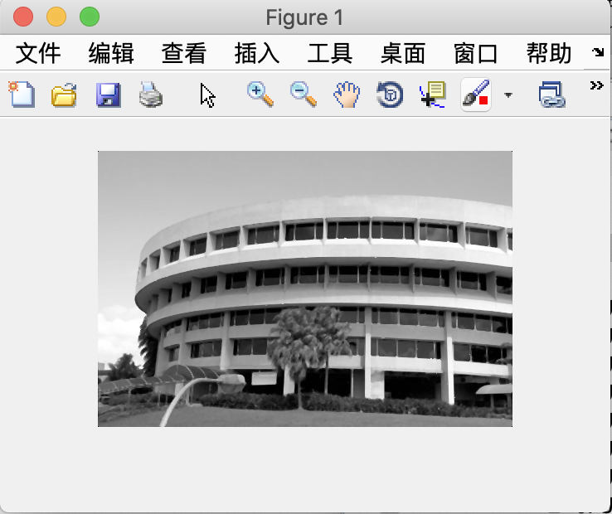

How does Gaussian filtering compare with median filtering in handling the different types of noise? What are the tradeoffs?

很显然中值滤波更适合处理speckle noise.